**MARKETING AND ADVERTISING**

* Marketable markets
* Searching and researching
* Slept approach
* The whole world in your hand
* A brand new brand
* Promote advertising
* With the communication agency

1. **Marketing and advertising**

Marketing & adversiting are essential components of any successful business. These practices help 3 target audience and promote their products or services effectively. To archieve this, businesses must identify marketable markets, conduct thorough research, and develop a strategic approach to advertising.

One approach to marketing and advertising is the “slept” approach, which stands for segmentation, targeting, positioning and timing. This method involves dividing the market into smaller segments, identifying the most profitable targets, positioning the product or service in a unique way, and timing the advertising to maximize impact.

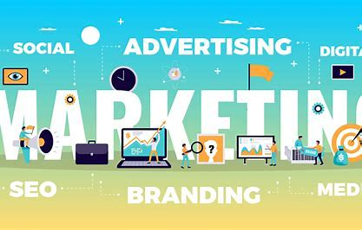

Figure 1 illustration

1. **Searching and researching**

Research is also crucial to successful marketing and advertising. Companies must conduct market research to understand their target audience, competitors, and market trends. They can use various methods such as surveys, focus groups, and online analytics to gather data and insights.

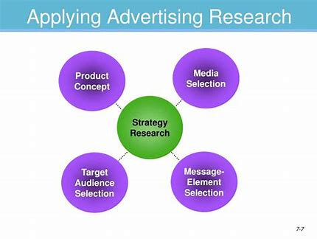

Illustration 2

1. **Slept approach**

The slept approach in marketing is a strategy that involves segmentation, targeting ,positioning ,and the timing. This approach helps businesses to identify profitable market segments, target specific audiences, position their products or services uniquely, and time their advertising to maximize impact. By dividing the market into smaller segments and understanding the needs of each segment, businesses can create tailored messages that resonate with their target audience. The goal of the slept approach is to create a marketing strategy that is both efficient and effective in reaching the desired audience.



Figure 2 illustration

1. **The whole world in your hand**

The rise of digital technology has transformed the businesses approach marketing and advertising . With smartphones and the social media, companies can reach customers anywhere in the world. The phrase “the whole world in your hand” reflects this new reality, where costumers have access to a vast array of products and services at their fingertips.



Illustration

1. A brand new brand

As businesses adapt to this new landscape, they must also develop new brands that resonate with consumers. A brand is more than just a logo or slogan; it’s an identity that represents the values and the personality of company. Developing a brand requires careful consideration of the target audience, market trends, and the competitive landscape.



Figure 3 illustration

1. **Promote advertising and the communication agency.**

Finally, promotion advertising requires collaboration with communication agencies. These agencies specialize in creating compelling content that resonates with consumers across multiple channels. Working with a communication agency can help businesses develop effective advertising campaigns that reach their target audience and drive sales. A communication agency is marketing is a company that specializes in creating and implementing communication strategies for businesses. These agencies work with clients to develop messaging, branding, and advertising campaigns that effectively reach their target audience. Communication agencies may also provide services such as media planning and buying, public relations, social media management, and content creation. They goal of a communication agency is to help businesses communicate their message clearly and effectively, ultimately driving sales and brand awareness.

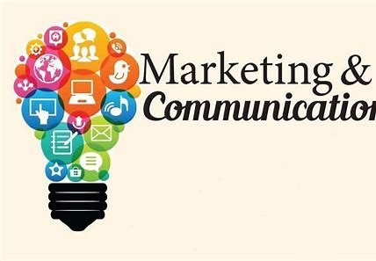

Illustration : communication agency

 

Illustration the promote advertising